Rare Six-Planet Star System Discovered in Milky Way

Worlds orbiting a sun-like star 100 light-years from Earth could unlock secrets surrounding the formation of our solar system

By Aylin Woodward

The Walll Street Journal

November 29, 2023

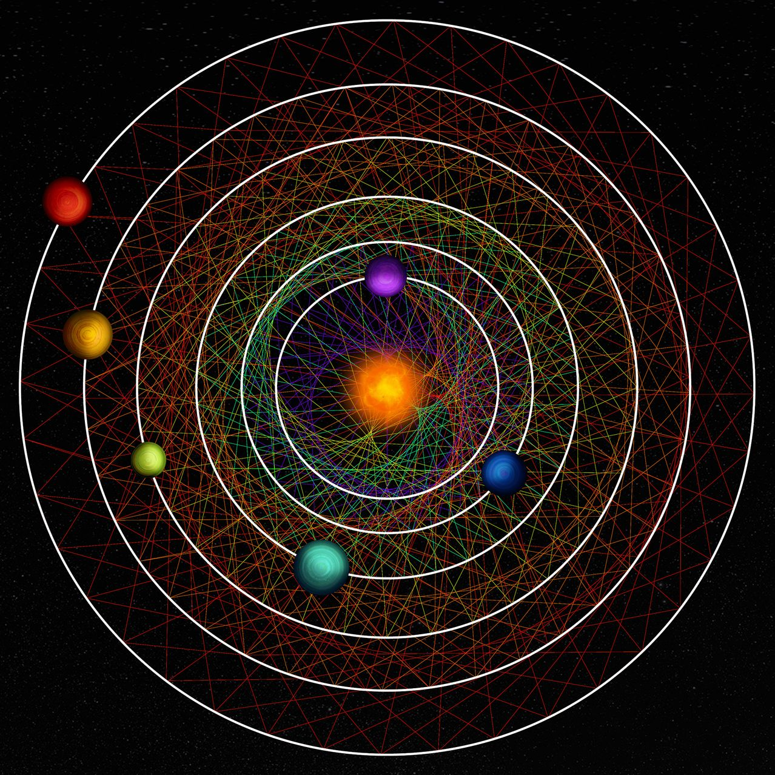

An illustration showing the six exoplanets of the HD 110067 system, located about 100-light years from Earth, and the relationship between neighboring planets’ orbits. Thibaut Roger/NCCR PlanetS

A family of six gaseous worlds circling like rhythmic dervishes around a sun-like star will soon help astronomers better understand how planetary systems like our own formed and evolved.

This newly discovered system, about 100 light-years from Earth, is unusual because its planets orbit a bright host star in a pattern that appears unchanged since its birth at least 4 billion years ago, according to a study published Wednesday in the journal Nature.

“It offers an opportunity to study an early stage of a planetary system’s orbital architecture,” said Tansu Daylan, an assistant professor of physics at Washington University in St. Louis, who wasn’t involved in the new research.

In 2020, scientists observed some of this bright star’s light dimmed every so often—suggesting one or more orbiting exoplanets were passing in front of it, a term known as transiting. The star was monitored by a National Aeronautics and Space Administration space telescope known as TESS.

Exoplanets, the name given to the more than 5,000 planets now discovered outside our solar system, come in myriad types. The most common in our galaxy are called “sub-Neptunes”—worlds that are larger than Earth but smaller than Neptune that scientists think likely have solid cores with gassy atmospheres.

Additional observations of the star, designated HD 110067, from TESS and a European Space Agency telescope named CHEOPS in 2022 not only confirmed the presence of six transiting sub-Neptunes, but that these cosmic constituents exert gravitational influence on each other, orbiting in a pattern. Astronomers call this resonance—a configuration that is rarely preserved as a multiplanetary system evolves over time. The planets in our solar system, for instance, are not in resonance.

An animation showing the orbits of six planets around the star HD 110067. The orbits and planetary sizes are to scale relative to each other, although not relative to the size of the star. VIDEO: Hugh Osborn/University of Bern

For every three rotations around HD 110067 completed by the innermost planet, the second-closest planet completes two, the study authors reported. The same pattern exists between the second and third and third and fourth planets, while a ratio of four-orbits to three-orbits exists between the fourth and fifth and fifth and sixth planets.

This chain of orbital relationships gives clues about the six-planet system’s past, according to Rafael Luque, a University of Chicago astrophysicist and lead author of the new research. Host stars and their planets are born at the same time out of a cloud of gas and cosmic dust that starts to flatten into a disk shape, he said. Most of the gas comes to the center, where a star forms, while baby planets form on the disk’s outskirts from dust. Those planets, when they first form, tend to be in resonance to help keep the system gravitationally stable.

“The fact that exoplanets are rarely found in these resonances is what really grabs me,” said David Kipping, an associate professor of astronomy at Columbia University who wasn’t involved in the study. “It suggests that dynamical disruption to these primordial, pristine states is a common outcome of planet formation—and so we are left with precious few of these relics, time machines to how planets are born.”

Observations suggest only one in 100 systems or so have retained their resonance through to the present day, Luque said. Typically, some chaotic disturbance—perhaps an asteroid impact or the formation of a giant planet like Jupiter with a strong gravitational pull—quickly destroys the pattern after a system is born.

That HD 110067’s planets are still in resonance suggests the system has remained unchanged for billions of years, Luque added, and may provide hints as to what conditions allowed it to maintain that stability—and what conditions ensured that our solar system did not.

The four outer planets in our solar system—Jupiter, Saturn, Uranus and Neptune—likely once had an orbital resonance resembling that of this six-planet system before their orbits violently changed around 4.5 billion years ago, Luque said.

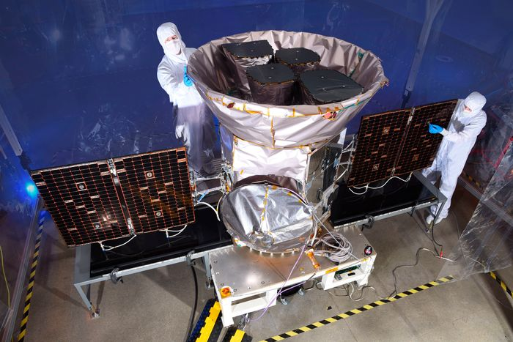Technicians work on NASA’s Transiting Exoplanet Survey Satellite, or TESS, prior to its launch in 2018. Photo: NASA

Other multiplanetary systems in resonance have been discovered before, but this is the first one with a host star bright enough to enable scientists to do follow-up studies to measure the mass of these sub-Neptunes and probe what molecules are present in their atmospheres with extreme precision, both the study authors and outside experts said.

While the atmospheres of Jupiter-sized exoplanets have been studied in great detail, “planets as small as those in the HD 110067 system are more mysterious,” said Howard Isaacson, a University of California, Berkeley astronomer who wasn’t involved in the research.

NASA’s James Webb space telescope, among others, could help characterize the atmospheres of these six new exoplanets, according to Isaacson and Luque, perhaps observing molecules like methane, carbon dioxide, water and ammonia.

“This planetary system gives us the best chance at understanding the chemical composition in the atmospheres of small planets,” said Thomas Wilson, a University of Warwick astrophysicist and a co-author of the study. “This could then inform how small planets such as the Earth and Neptune both formed and evolved over time.”

